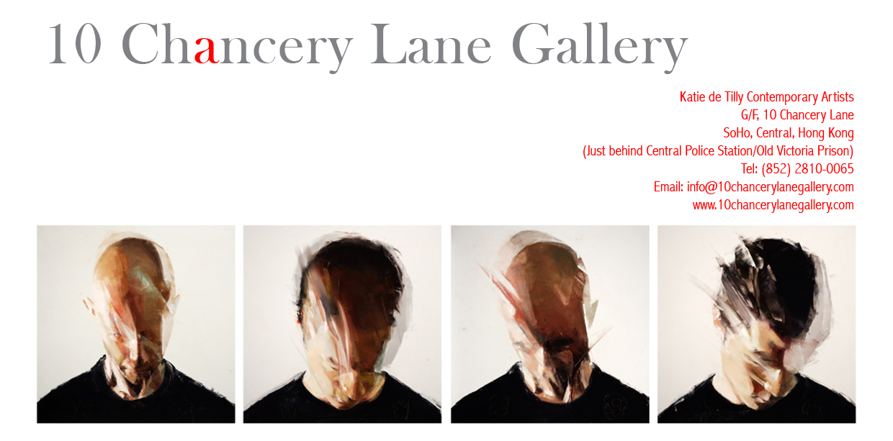
Attn: ART EDITORS
PRESS RELEASE

OPENING THIS FRIDAY 18th APRIL, 2008
‘THIS BRUTAL HOUSE’ AN ART INSTALLATION BY
SIMON BIRCH.
AND THE LAUNCH OF HONG KONG’S NEWEST ART SPACE: 10 CHANCERY LANE GALLERY ART PROJECTS

APRIL 18 2008, Hong Kong—For the launch of 10 Chancery Lane Gallery Art Projects we are proud to present Simon Birch’s first major multi-media exhibition entitled “This Brutal House,” incorporating photography, video, live performance, installation and paintings. This is a 3-part exhibition taking place at 10 Chancery Lane Gallery (Central) with bus service to 10 Chancery Lane Gallery Annex (Chai Wan) and the new 3000 sq. foot space, 10 Chancery Lane Gallery Art Projects (Chai Wan).

Birch, traditionally a painter was inspired to create ‘This Brutal House’ while thinking about fun fairs, fun houses, haunted houses and circuses and how they created an escape for the participant. This ‘escapism’ is a pivotal element to this exhibition as is the drama and spectacle of the environment. Birch creates a rollercoaster of events of thrill-seeking elements to engage his audience and sometimes repel them by the violent nature of the attractions. This very literal theme goes deeper into Birch’s ongoing dialogue on transitional moments leading to areas of extreme emotion and the need to escape, which leads us into the desire of taking risks playing with life and death as our entertainment.

The Attractions:
Birch’s use of the 360-degree film is disorientating as it takes you through the streets of Hong Kong in fast motion over 24 hours. The film made by driving on the same circuit all over Hong Kong represents the life’s fast paced journey while stopping from time to time to ponder the slow motion clips. Three additional videos are singular in their subject, each one focuses solely on the rawest of emotions and the resulting turmoil experienced by the viewer can be considered another ride.

Other elements of the carnival that are explored in the exhibition are games of chance and curiosity. A photographic collaboration with Wing Shya is a direct extension of the children’s game of ‘lucky dip’. It takes place in an enclosed booth and both Wing Shya and his subject, a leaping girl, are hidden entirely from the viewer. The resulting Polaroid photograph is a surprise treat given to reward the viewer for participating or playing the game. The paintings of the girls suspended in space, leave the viewer to decide whether they are falling or flying. The uncertainty is unsettling yet there is no doubt regarding the painting’s inherent beauty.

Simon Birch is the show’s ringmaster. His vision is further realized by his orchestration of several performers and by an epic display of Siamese fighting fish. Not content with elegant goldfish, (a traditional prize at British fun fairs), these fish despite their beautiful appearance, have a violent and aggressive nature.

‘This Brutal House’ looks beyond the frivolity of the carnival and delves into questions of where beauty lies, it is the artist’s conviction that it can be found within all dramatic emotional scenarios.

“All my work has always been about these central things: spectacle, transition, life and death, brutality and beauty. The whole show has all these elements… it’s all connected and interwoven” Simon Birch

The launch opening will take place in all three venues – 10 Chancery Lane Gallery (Central), 10 Chancery Lane Gallery Annex (Chai Wan) and the brand new 10 Chancery Lane Gallery Art Projects (Chai Wan).

April 18, 2008: The gallery is organizing mini-busses from 10 Chancery Lane Gallery (Central) to and from Chai Wan from 6:30-11pm.

For Press enquiries and to schedule interviews please call Eliette Rosich on 9551 1240.
Or email eliette@10chancerylanegallery.com
