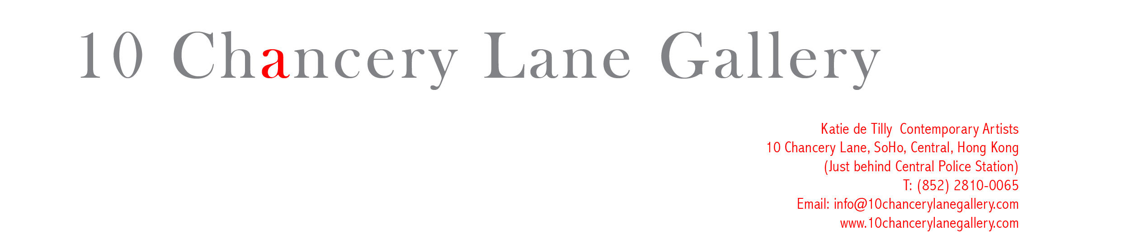

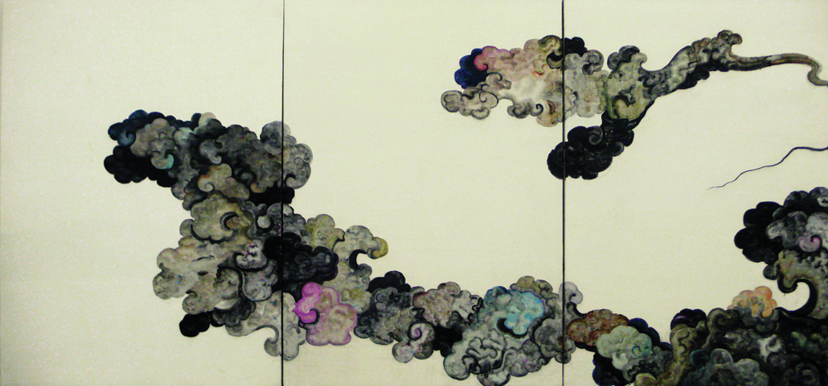

Shao Yinong, Between Sky and Earth- Beginning of Summer, 2008, Oil on Silk

PRESS RELEASE - ARTS / FEATURES EDITORS

BETWEEN SKY AND EARTH – WHITE DEW
by SHAO YINONG

4 September – 11 October, 2008.
10 Chancery Lane Gallery, Central, Hong Kong.

Artist Shao Yinong explores social terms of the Chinese Lunar Calendar.

10 Chancery Lane Gallery presents new paintings by Chinese Artist, Shao Yinong.

The exhibition Between Sky and Earth-White Dew, captures the sense of autumn and nature moving gracefully from hot to cool. In one part of a twenty-four part exhibition, planned internationally, in which the artist explores the traditional Chinese Lunar Calendar.

“White Dew” is the first solar date on the Chinese Lunar Calendar that signifies the sudden change in temperature when autumn begins. From this date onwards, the evening temperature drops significantly thus forming morning dew so dense that it appears white.

The work itself consists of one continuous painting on silk painted directly on the walls and passageways of the gallery. His work combines elements of illusion, luck and inward reflection. Its presentation is designed to enable visitors to find a sense that belongs to the visitors themselves, and to evoke the vision and concept of the modern Eastern world.

Shao Yinong’s paintings offer a fresh interpretation of traditional Chinese ideology. His contemporary presentation of traditional philosophy within the gallery space emphasizes the interaction of human beings in relation to the heavens and earth.

About the Artist:
Shao Yinong (b. 1961, Qinghai, China) is one half of the powerful artist duo Shao Yinong & Muchen, most famous for their photographic series The Assembly Halls. The artist currently lives and works in Beijing. Their works have been internationally exhibited at the Groningen Museum in The Netherlands, the Pompidou Center in France, the Queensland Art Gallery in Australia, the Mori Museum in Japan, the Shanghai Art Museum in China, the Israel Museum and the San Diego Museum of Art in the U.S. to name just a few.

Katie de Tilly cordially invites members of the press to the opening reception at 10 Chancery Lane Gallery in Central that will be held on September 4, 2008 (Thursday) from 6:30-8:30pm. Shao Yinong will be available for interviews with the press from August 25 until August 28.

For press enquiries and interviews please call Eliette Rosich on 9551-1240 or 2810-0065, or eliette@10chancerylanegallery.com

Artist, Shao Yinong
Between Earth and Sky – White Dews
Exhibition runs from 5 September – 11 October 11, 2008
Opening 6.30pm – 8.30pm, 4 September 2008.
10 Chancery Lane Gallery,
Central, Hong Kong 2810 0065

