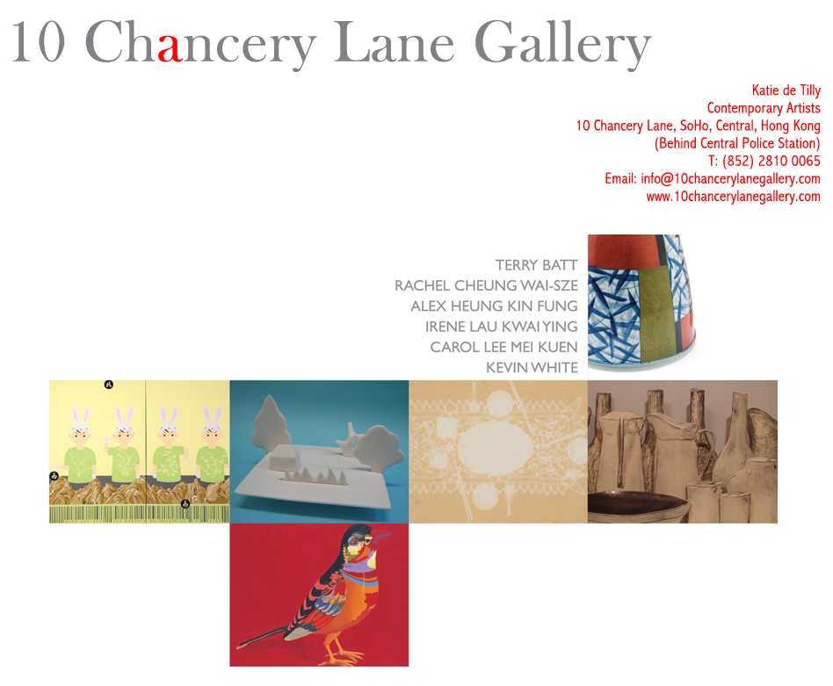
Press Release
Attn: Editors

NEW HORIZONS, HONG KONG ARTISTS AND THEIR MENTORS EXHIBITING AT 10 Chancery Lane Gallery, Hong Kong

Hong Kong, September 19, 2008 – 10 Chancery Lane Gallery presents a group show combining Australian and Hong Kong artists. Royal Melbourne Institute of Technology (RMIT) professors Terry Batt and Kevin White who have had a long engagement in arts education in Hong Kong through the collaborative undergraduate and postgraduate degree programs in Fine Art co-taught with the Hong Kong Art School, have each chosen two former students who will exhibit with them at 10 Chancery Lane Gallery-Art Projects in Chai Wan.

Terry Batt
Terry Batt is an inveterate traveller, his time over the past 5 years has been divided between his hometown Melbourne, Australia, France, Vietnam, Hong Kong, Thailand, USA and Beijing. His most recent work explores the relationships between diverse cultures both within a contemporary and historical context. His colorful figurative paintings are a peculiar arrangement of strange figures that play upon the canvas. References to tin toys and traditional Chinese ceramics provide recurring metaphors in his new works with implied social and political meanings that are both whimsical and subversive at the same time. Terry Batt has been exhibiting regularly since 1974 and has been included in important group exhibitions in Australia and overseas. He is an Associate Professor in Fine Art at RMIT and regularly travels to Hong Kong where he supervises post-graduates enrolled in the international program. His work has been acquired in international collections such as the Chartwell Collection at the Auckland Museum of Fine Art in New Zealand, the Lim Lip Museum in Korea, the National Gallery of Victoria in Melbourne and the National Gallery of Australia in Canberra.

Rachel Cheung Wai-sze
Rachel Cheung’s ceramic work shows a sense of vulnerability and precariousness. Mountains, form a balance between the level of the water in flat soft white planes. With this sense as a metaphor, she reminds viewers of the concept of equilibrium. The exhibiting work links the equilibrium state to a delightful aura. Cheung was the winner of the Prize of Excellence of the 2001 Hong Kong Art Biennial, received an honorable mention at the World Ceramic Biennale 2005 Korea, invited to participate in the ‘International Biennale of Contemporary Ceramic 2006’, Vallauris, France, and was finalist for the Philippe Charriol Foundation Art Competition.

Alex Heung Kin Fung
Image is an important element in Alex Heung’s paintings. One image combined with another image can represent not only the individual meaning of each separate image, but also the message represented by the relationship between the two images created. This relationship exists when one story meets another story, when tradition meets the contemporary, when east meets west, when design meets fine art, when abstract meets figurative. Alex Heung’s background is in design where he is a full member of the Hong Kong Designers Association. His goal is to integrate both design and art in his works. He is a part-time lecturer at the HK Art School as well as the HK Ching Ying Institute of Visual Arts.

Irene Lau Kwai Ying
Still life images from magazines, computer screens and so forth, allow the eye to visualize their real life forms. It is with this idea in mind that Irene Lau creates her panorama of ceramic works both in two and three dimensions. Painting transforms 3D objects onto 2D canvas yet the painting has depth having a realistic quality. Irene’s interest lies in these dimensional changes; employing the reversal of 3D into 2D Lau’s works confuses our perceptions.

Carol Lee Mei Kuen
The works by Carol Lee Mei Kuen represents a diary using paper. The paper is changed to yellow using sunlight and with each passing day records the passing of time. It is not only a visual diary but also a way of collecting and measuring time. Time is abstract, we know only of its passing through sunrise and sunset. Carol Lee Mei Kuen makes her works by placing objects on newsprint under the sun and allows the sun to create her pictures as the newsprint yellows on the surface. Minimalist images are transferred through the filter of the objects on paper. Through this process it will enter into an everlasting journey of contingency and transmigration. Lee is an active member of the Hong Kong art scene and has been twice awarded for her glass works by the Corning Museum of Glass and is a recipient of the Philippe Charriol award.

Kevin White
Kevin White’s work continues his interest in interpreting the ceramic traditions of Japan and the Japonisme seen in British ceramics of the 19th century. While his earlier works focused on the blue and white decorative traditions of Arita, this more recent work introduces planes of colour through geometric reserves and panels and the introduction of decal patterning into the formal spatial organisation of the vessel’s surface. He has been exhibiting successfully since 1980, and is currently Associate Professor, School of Art, RMIT University and Program Director for the BA(Fine Art) in both Melbourne and Hong Kong.. His works are collected internationally and are in the collections of the National Gallery of Australia; National Gallery of Victoria; Powerhouse Museum, Sydney; Gifu Prefectural Ceramic Museum, Gifu, Japan, to name a few.

Katie de Tilly cordially invites members of the press to the opening reception with the artists at 10 Chancery Lane Gallery Art Projects in Chai Wan, that will be held on September 19, 2008 (Friday) from 7-10pm. Free shuttle busses between 10 Chancery Lane Gallery Central and Chai Wan every 15 minutes from 7-10pm.

For press enquiries and interviews please call Eliette Rosich on 9551-1240 or 2810-0065, or eliette@10chancerylanegallery.com

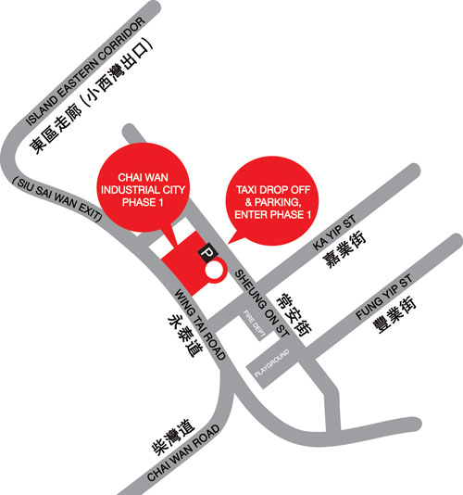

NEW HORIZONS
Exhibition runs from 20 September – 18 October, 2008
Opening 7 – 10pm, 19 September 2008. (Friday)
10 Chancery Lane Gallery Art Projects
Unit 603-605, Chai Wan Industrial City Phase 1
60 Wing Tai Road, Chai Wan

Free shuttle busses between 10 Chancery Lane Gallery Central and Chai Wan
every 15 minutes from 7-10pm.
Driving: Exit Siu Sai Wan from Island Eastern Corridor

