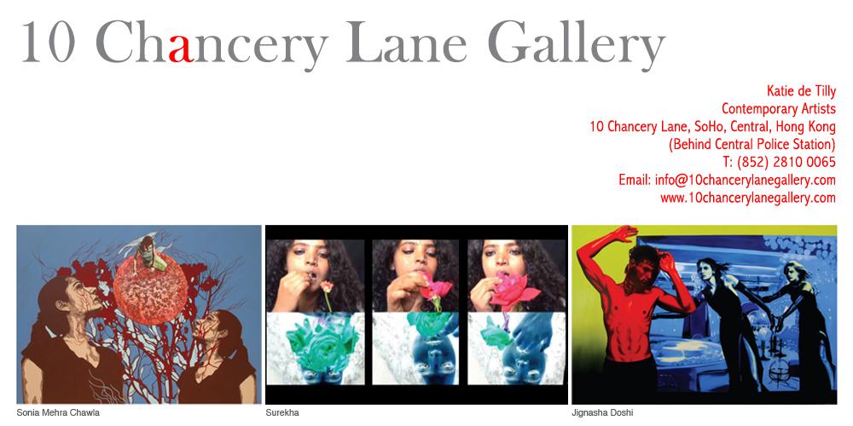

PRESS RELEASE – PREVIEW
ATTN: ART EDITORS

THE SECOND SEX, INDIA.
An exhibition of new paintings, photography and video by three female Indian artists will open on Thursday, 23 October, until 22 November 2008 at the 10 Chancery Lane Gallery in Central, Hong Kong.

The Second Sex (French: Le Deuxième Sexe, June 1949) is one of the best known works of the French existentialist Simone de Beauvoir. It is a work on the treatment of women throughout history and often regarded as a major work of feminist literature. In it she argues that women throughout history have been defined as the “other” sex, an aberration from the “normal” male sex.

Looking into “The Second Sex: India” one thinks of the many complexities that women still face around the world since the writing of Simone de Beauvoir’s book in 1949. Join us for this exhibition of three incredible female artists working independently as woman and viewing the world through their eyes.

Sonia Mehra Chawla b. 1977, Kolkata, India.
A formally trained painter with a Master of Fine Arts from the College of Art in New Dehli, mixed media artist Sonia Mehra Chawla has developed a style uniquely her own combining print making techniques, photographic references and painting using acrylic paints, oils and inks. In the work created for this exhibition “The Meamorphosing Female-Contemplations on production, reproduction and the Womb,” she contemplates the thought stated by de Beauvoir, “Woman is neither exclusively a worker, nor exclusively a womb.”

Jignasha Doshi b. 1973, Gujarat, India.
Accomplished painter, and holder of a Masters of Fine Arts degree from the MS University in Baroda, Jignasha Doshi’s bold and brightly coloured paintings for this exhibition, focus on the role of women in society. These works place women at the forefront of the compositions, with scenes of urban life in the background. The resulting tension reflect Doshi’s view of the ‘packaging’ or ‘showcasing’ of women in contemporary Indian society.

Surekha, born in Bangalore, India.
Video artist and photographer, Surekha, despite her many residencies in places as diverse as Trinidad and Vermont, USA, continues to work in Bangalore and her work remains true to her Indian identity. The images in these new works focus on the emotional and internal life of women. The resulting works are sensual and intimate and as such the viewer feels that they have been given an insight into workings of this private world.

For interviews and press enquiries, please contact eliette@10chancerylanegallery.com
Or telephone +852 9551 1240

