10 Chancery Lane Gallery
Katie de Tilly
Contemporary Artists
10 Chancery Lane
(Behind Central Police Station)
SoHo, Central, Hong Kong
T: (852) 2810 0065
Email: info@10chancerylanegallery.com
www.10chancerylanegallery.com

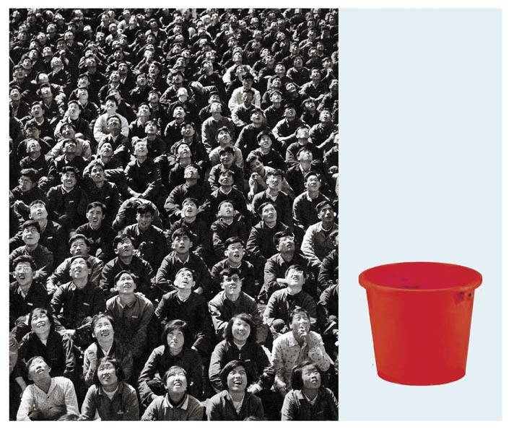

PRESS RELEASE
ATTN: ART EDITORS

JOHN YOUNG – 1967DISPERSION, An exhibition of Hong Kong born artist John Young’s new paintings will open on Thursday 27 November, 2008 at the 10 Chancery Lane Gallery in Central, Hong Kong.

Over the past three decades, John Young’s work has culminated as one of Australia’s most engaging and prolific artistic statements. Yet, neither was it forgotten that the driving impetus of his work holds much to his position as a figure within the Hong Kong diaspora.

From his first exhibition, a minute show held in the tiny fishing hamlet of Rosroe, Ireland, to numerous projects based on pilgrimages and travels to extreme localities: Manchuria, the central western desert of Australia, Antarctica, Young has searched ways of giving form to the diasporian condition.

The value in Young’s work – a keen sense of form, a brave synthesis of content; a consideration of technology, it’s relationship to affection; and the melancholy inherent in the spirit displaced that find their roots in his bi-cultural experience.

Born of Southern Chinese parentage, in the then British colony of Hong Kong, Young moved to Australia in 1967. Through out his career as an artist, his work has equally engaged theoretical concerns but also the pleasure of painting. His investigation of Western late modernism prompted significant phases of work from a bi-cultural viewpoint. His evolving concerns with discourses of the time, including postmodernism and post colonialism, and the ongoing tensions surrounding globalization, have contributed to intriguing cycles of work.

Young’s intellectual rigor combined with a fundamental commitment to painting, make him one of the most fascinating and respected artists working in today’s world. The many international exhibitions of his paintings reflect his status. They include exhibitions held at the Queensland Art Gallery, the Za Moca Foundation in Tokyo, the National Museum of Contemporary Art in Seoul and in 2005 a large survey exhibition of John Young’s work was held, entitled Orient/Occident at the TarraWarra Museum of Art, in Australia. This retrospective co-incided with the publication of his monograph, published by Thames and Hudson.

In his second solo show at 10 Chancery Lane Gallery, the exhibition; 1967DISPERSION looks back at the origins of the dispersal of Hong Kong citizens around the world and the drastic condition of Hong Kong in the 1960’s.

For interviews and press enquiries, please contact eliette@10chancerylanegallery.com
Or telephone +852 9551 1240

