FOR IMMEDIATE RELEASE

10 Chancery Lane Gallery presents new works by
Chinese Performance Artist LI WEI in BEYOND GRAVITY
With a special performance co-presented by
Chinese Luxury Brand, SHANGHAI TANG during ART HK 10

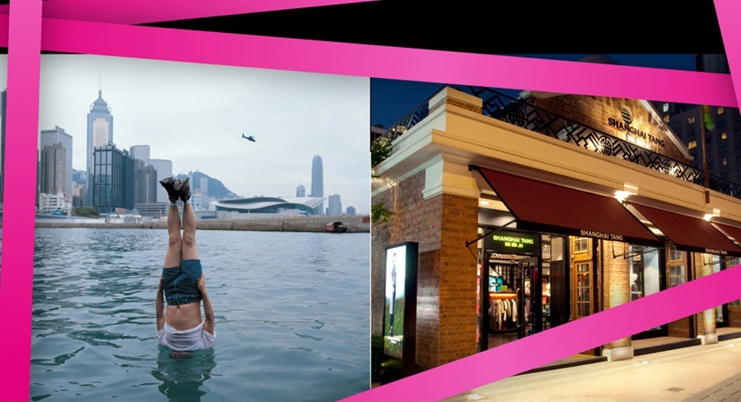

May 27, 2010 HONG KONG—LI WEI has been seen hanging upside down with his head under water from Italy to Hong Kong, falling off buildings in Beijing and New York and even crashing head first through car windows to communicate his artistic message through daring performances.

In this exhibition, BEYOND GRAVITY, Li Wei continues to awe with unexpected freshness exploring current day issues that effect him and society in general. “Beyond Gravity” deals with desire. The desire of wanting material goods, the desire for love’s lost innocence, the desire for power. Li Wei communicates his messages profoundly without language. He is seen flying away with a BMW, a dozen collaborators pulling at his heels. He is the arrow with his female cupid shooting him out of a luxury car. He is also the reflection in his iconic mirror, where he sticks his head through a well cut hole, showing us both the past nostalgia of the Hou Hai lake buildings of Beijing and their modern day conversions into trendy bars and restaurants inside.

Li Wei is very particular about his performances and every detail of their staging is well thought out. He does not want to be perceived as a circus act and the depth of the meaning of his work is at the heart of each performance. Eleanora Battiston has said of his work, “His photos always immortalize him at the very limits of the absurd and are stupendous for their originality that, at times, borders on madness.” And indeed some of the physical acts that Li Wei endures are pure lunacy. He laughs pointing to scars on his arms and neck and tells stories of passing out while upside down with his head in a roughly cut glass floor suspended by a rope. There is very little retouching done to his work, besides erasing a cable or a rope that suspends him, and it is startling to know that he does do every act.

The levity of Li Wei’s performances is not absent of wit and humour. His Beyond Gravity series will include a live performance starting at 7:30pm sharp on Thursday, 27 May 2010 at the SHANGHAI TANG flagship boutique in Hong Kong located in the 1881 Heritage Building of Tsim Sha Tsui. The highly ambitious project attempts to wrap the entire old fire house now converted into a luxury shop and Li Wei will fly into the sky, with everything in tow. The title of the work, “Take Away,” touches on our desire of wanting and in that wanting there are no limits. Shanghai Tang Executive President, Raphael le Masne de Chermont says, “At Shanghai Tang we have always redefined trends, bringing together Chinese cultural elements and contemporary style to create a truly revolutionary lifestyle concept. As the global ambassador of contemporary Chinese chic, we proudly support creative talents from China; Li Wei is the perfect example of a leading visionary that has captured the world, much like Shanghai Tang itself.”

About Shanghai Tang
Since its inception in 1994, Shanghai Tang has been the pioneering luxury lifestyle brand from China. With its mission as the global ambassador of contemporary Chinese Chic, Shanghai Tang interprets Chinese culture and craftsmanship with a vibrant sophistication. Offering ready-to-wear for women, men and children, as well as accessories and home ware, Shanghai Tang supports an international network of 40 boutiques in the world’s most prestigious shopping districts.

About 10 Chancery Lane Gallery
Founded in 2001, 10 Chancery Lane Gallery is a driving force in contemporary culture in Hong Kong and is one of Asia’s leading contemporary art galleries. Working from a broad range of artists of culturally diverse backgrounds the gallery is particularly interested in emerging movements in Asian art. Asia has seen a blossoming of its art over the last decade and 10 Chancery Lane Gallery is committed to play a major role in documenting the development of art within the Asia-Pacific region by holding survey exhibitions by country or theme of both emerging and mid-career artists and publishing books that bring together the individual historical context with the arts development within Asia.
About Li Wei

LI WEI (Hubei, 1970) lives and works in Beijing. Since 2000 he has regularly shown his work in China, the U.S. and Europe in private galleries, museums and institutional centers. Exhibitions include Open Art Platform at the Performance Art Festival, 2000, Constructed Reality - Beijing/Hong Kong Conceptual Photography at the Hong Kong Arts Centre, Scar - Chinese Conceptual Photography at the Exhibition Hall of Capital Normal University, 2001, and Flying – Performance, Photography, Videos, Beijing Red Square, 2002.

Abroad he has been included in shows such as Mois de la Photo. Histories de Chine in Auxerre, France, 2002, China Art Now. Out of the Red at the Flash Art Museum in Italy and the Prague Biennial, 2003, Between Past and Future. New Photography and Video from China in ICP, Asia Society, New York and Smart Museum of Art, Museum of Contemporary Art of Chicago, Officina Asia at Galleria d’Arte Moderna Cesena, Bologna Italy. Other recent exhibitions include Tiananmen, in Paris, and MMAC Japan, Artificial Merriment Melbourne Australia, 2004, and Between Past and Future at the Seattle Art Museum, the Victoria and Albert Museum, London, 2005, “Beijing 2008”, Olympic Museum, Lausanne, Swiss 2008, Olhares Interiores – Inward Gazes”, Documentaries of Performances Art – Museum of Macao, Macau 2008 and the China: the Contemporary rebirth”, Palazzo Reale Museum, Milan, Italy 2009

For press inquiries, please contact

10 Chancery Lane Gallery
Celine Ho Tel: +852 2810 0065 Email:celine@10chancerylanegallery.com

Shanghai Tang
Annie Ho Tel: +852 2839 0809 Email: annie.ho@shanghaitang.com
Coco Lau Tel: +852 2839 0842 Email: coco.lau@shanghaitang.com

